

Student Name: Charlie Coad (20102084)
Module: Business Intelligence and Data Visualisation
CA No.: 1
Lecturer: Syed Rizvi
Submission Date: 01/05/2026
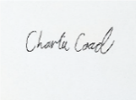
Signed: Date: 01/05/2026

Table of Contents
1. Introduction: 3
2. Data Collection and Preparation 3
Importing and transforming the data in PowerBI’s Power Query 6
Remove irrelevant columns: 6
Splitting Columns: 7
Replacing missing values: 8
Renaming columns for clarity: 8
Correcting data types: 9
Implementing new Measures and Columns using DAX Formulas: 10
3. Creating Reports and Graphs on the Reports Dashboard: 11
Overview Page: 11
Q1. Artists 17
Q2. Valence 19
Q3. Valence continued… 20
Q4. Duration Page: 22
Q5-Q7 (Popularity) Page: 23
Q8. Copies Sold 26
4. Conclusion 29

Audit Trail for Music Database Analysis.

Introduction:
For this Assignment I decided to analyse a Music Database for a Record Label that wants to analyse the current trends in the music industry. The objective for this analysis is to understand and analyse how Artists, Valence, Duration, Popularity and Copies sold all contribute to music being in the Top 10000 on Spotify and to gain insight into the current state of the music industry. It is also important that we can analyse this in multiple genres of music as each genre has a different audience it appeals to, different sounds and cultures surrounding it that need to be taken into account.

Data Collection and Preparation
Data was sourced from “Kaggle” created by the User: “Serkan Tüysüz” consisting of the top 10,000 songs of 2025 as it highlights the current trending songs, albums and artists in the music industry now as well as statistics related to those songs.
This Dataset can be accessed at: https://www.kaggle.com/datasets/serkantysz/annas-archive-top-10k-spotify-songs-metadata-2025?select=top-10k-spotify-songs-2025-07-detailed.csv

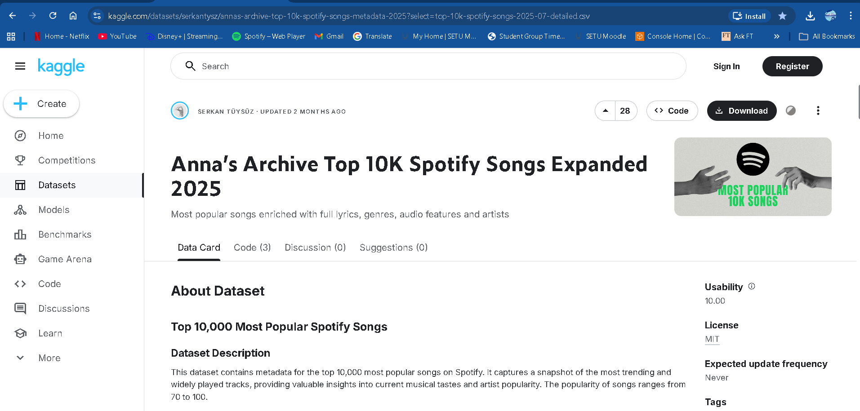
Size:
This dataset currently contains 10,000 rows and 32 columns.
Column Descriptions:
According to the Creator of the Database: “Serkan Tüysüz” the column and descriptions consist of the following:
Column | Description
rank | Position in the Top 10,000 list.
popularity | Current popularity score (0-100).
duration | Song duration in human-readable format.
explicit | Whether the track contains explicit content (1=Yes, 0=No).
release_date | Date of release.
album_type | Type of release (album, single, compilation).
isrc | International Standard Recording Code.
copies | Estimated number of copies/sales.
danceability | Suitability for dancing (0.0 to 1.0).
energy | Intensity and activity level of the track.
key | The key the track is in using standard Pitch Class notation.
loudness | Overall loudness in decibels (dB).
mode | Modality (Major=1, Minor=0).
speechiness | Presence of spoken words (0.0 to 1.0).
acousticness | Confidence measure of acoustic nature (0.0 to 1.0).
instrumentalness | Probability that the track contains no vocals.
liveness | Probability that the track was recorded with an audience.
valence | Musical positiveness/happiness (0.0 to 1.0).
tempo | Estimated tempo in beats per minute (BPM).
duration_ms | Song duration in milliseconds.
time_signature | Estimated overall time signature.
total_artist_followers | Total combined followers of all artists on the track.
avg_artist_popularity | Average popularity score of the artists.
artist_genres | Original granular sub-genres from Spotify.
main_genres | Standardized high-level parent genres.
lyrics | Full textual lyrics of the song.

Importing and transforming the data in PowerBI’s Power Query
Next I imported the data into PowerBI as it was one detailed CSV file. Upon opening the data and selecting the “Transform data” button, I am greeted with the full view of Power Query I made the following changes:

Remove irrelevant columns:
First I will remove columns that will not be utilised within this analysis. Those being:
- track_id,
- artist_id
- album_id,
- isrc
- duration_ms
- artist_genre
- lyrics
Next I noticed rows of data with complete null values and replace them with 0 where appropriate as these songs were popular ambiance audio on Spotify rather than music.

Splitting Columns:
I then wanted to simplify the current main_genre column as it contained multiple genres being mention in a single cell. To do this I first split the column by delimiter to separate each word. However I would need to rectify specific cells where a genre might be a 2 word phrase for example Hip-Hop, New Age etc… Then I would delete the extra rows as for the sake of this analysis I am only going to group each song, album and artist into a single genre.
Below we can see a before and after.

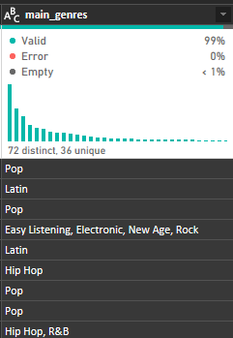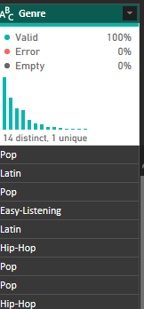

I will then split the column artist_name as there are some songs that are sung by the main artist and then a featured artist. I did this my selecting a custom delimiter and separating by the “|” key. This resulted in 4 separate columns as some songs had 4 artists. For this analysis I will only use the main artist and the featured artist. I then titled and named this column appropriately.
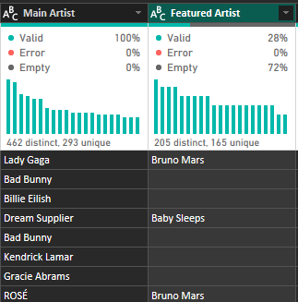

Replacing missing values:
Below we can see for any missing values in the Featured Artist column, I replaced this with the “\” key in order to signify that this is a blank column.
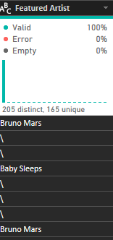

Renaming columns for clarity:
I renamed all the columns to reflect professional naming conventions for the analysis

Correcting data types:
Next I would ensure each table had the correct data type such as release_date and duration which needed to be set into date and time data respectively.
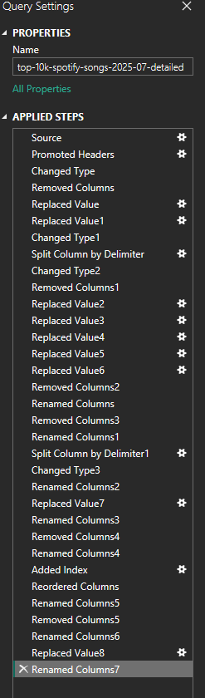
Now I selected the “close and apply” button in power query to finish my editing.

Implementing new Measures and Columns using DAX Formulas:

Now I’m going to create Measures that will allow me to better analyse specific columns of data:

Average Popularity:
This consisted of creating a DAX measure to calculate the average popularity value using the following DAX code: “Average Popularity = AVERAGE('top-10k-spotify-songs-2025-07-detailed'[Popularity])”

Average Valence:
This consisted of creating a DAX measure to calculate the average valance using the following DAX code: “Average Valence = AVERAGE('top-10k-spotify-songs-2025-07-detailed'[Valence])”

Most Popular Album:
This measure aims to utilise a DAX measure in order to display the Most Popular album by finding the Mode of the albums within the Album column, however as PowerBi doesn’t have a Mode function I needed to create a 2 variable’s in DAX in order to count the number of albums and then another variable that would Display the Top result of that column.

This was created using the following DAX code:
Most Popular Album =
VAR AlbumCounts =ADDCOLUMNS(VALUES('top-10k-spotify-songs-2025-07-detailed'[Album]), "AlbumCount", CALCULATE(COUNT('top-10k-spotify-songs-2025-07-detailed'[Album])))
VAR TopAlbum =TOPN(1, AlbumCounts,[AlbumCount],DESC )

RETURN MAXX(TopAlbum, 'top-10k-spotify-songs-2025-07-detailed'[Album])

Next I’m going to create Columns with the current dataset:

Track Count (Index Column)
This is a simple Index column that aims to count the amount of tracks/rows of data as the previous ID columns contained unsuitable integers. “DAX measure: Track Count = COUNT('top-10k-spotify-songs-2025-07-detailed'[Track])”

Energy Level:
This column aims to take the initial energy column which currently contains integer data and turn it into a categorical column which categorises the energy data into either “High Energy” or “Low Energy” based on if the figure is higher than or equal to 0.6 or not. The DAX measure for this is: “Energy Level = IF('top-10k-spotify-songs-2025-07-detailed'[Energy] >= 0.6, "High Energy", "Low Energy")”

Valence Score:
This column categorises the Valence column’s integer data by simplifying it into whether the mood level of a song contains low valence, neutral valence or high valence depending on the valence number. The DAX measure for this column was the following:
Valance Score = SWITCH(TRUE(),'top-10k-spotify-songs-2025-07-detailed'[Valence] < 0.4, "Low Valence (Darker / Sadder)",'top-10k-spotify-songs-2025-07-detailed'[Valence] < 0.6, "Average Valence”, “High Valence (Upbeat / Happy))

Creating Reports and Graphs on the Reports Dashboard:

Overview Page:
Slicer:
The first piece of content I wanted to create in the Report view was how the report would be categorised, I decided to create a Slicer with the field option utilising the Genre column with the Tile visual style at the top of the screen as I knew that this analysis would change depending on the musical genre. I gave this a title of Spotify Top 10,000 Analysis. Finally I wanted the colour scheme to reflect the Spotify colour scheme as I am analysing a Spotify database I believed it would be fitting. So I got the Spotify Hex colours and inserted them into the Background option under the General tab for Visualisations. This now looks like the following:
I want to highlight here that I am using Conditional Formatting for all pages to ensure the consistency between visuals and themes which is clear in its visuals. The theme I used for this Report is “Loomy Lime” which can be seen across each page. And will be utilising this Slicer on each page to allow Users to filter the Genres with ease.
Number of Tracks:
The next visual I made was a card that would display the number of songs being analysed which would change according to the genre being analysed. I did this by visualising the Track Count column using the card visual and titling it: “Number of Songs in this Genre” with the same colour format as the Slice with the Spotify colour scheme:
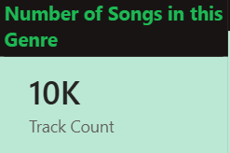
Most Popular Album:
The visual I created below Number of Track is what the most popular Album in this genre. Utilising the care visual and my Most Popular Album measure, it now displays the album that appears most in that column and changes depending on the genre you filter.
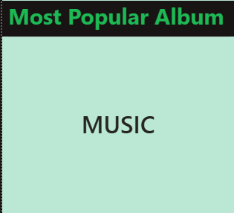
Song Information
I created a table that showcases all of the basic information regarding the song dataset such as the Track name, Main Artist, Featured Artist, Album and Sum of the main artists followers on Spotify.
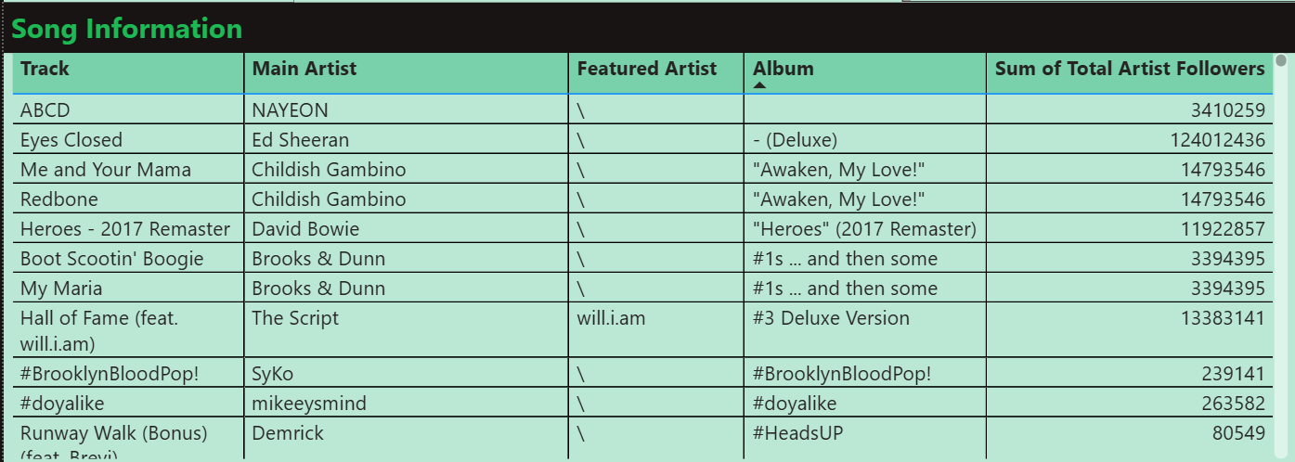

Music Personality:
Now I will create a visual that aims to view the Sum of the Danceability, Energy, Valence and Accousticness within the genre/s. To do this I selected the clustered bar chart visual where the Sum of the columns: Danceability, Energy, Valence and Accousticness, were placed in the X-axis. The Genre was then placed within the Y-Axis. Then I used the format painter to format the colours of the graph created the following visual:
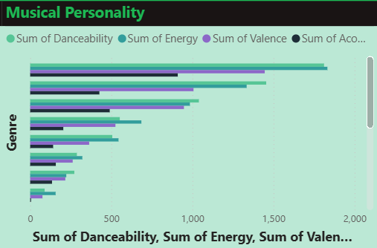
Popularity of the genre over the years:
The final visual I wanted to create for the overview report page was the Popularity of the genres over the years which I created using a line chart and putting the Release Date as the X-axis and the Average Popularity as the Y-axis. Then using the Genre column as the Legend. In the below visual I have selected the Hip Hop genre as without a genre selected is combines all of the genres into one graph which makes it incomprehensible:
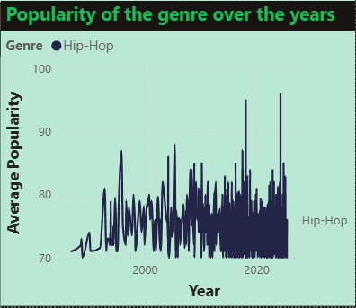
Analysis Sections (Navigation Menu)
I wanted to dedicate a section of this Overview page to having a section where the user can navigate to the different analysis pages. I have navigation buttons here that take you to the respective pages:
- Artists
- Valence
- Duration
- Popularity
- Copies Sold
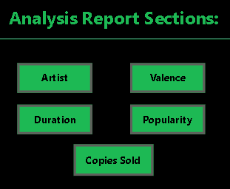
A “Home” button has also been added to every page going forward which will bring Users back to this page.


Filter customisation:
I customised the Filter to match the colour scheme of Spotify:
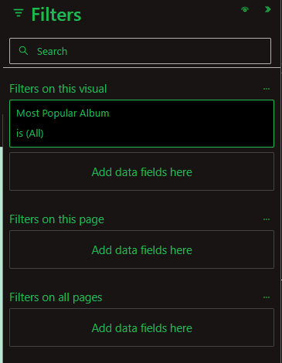
Zoom Sliders:
I have also added Zoom Sliders to several different graphs throughout this report in order to gain a better visualisation of the data as it does change drastically between genres and adjusting the slider allows the user to view the data more clearly.
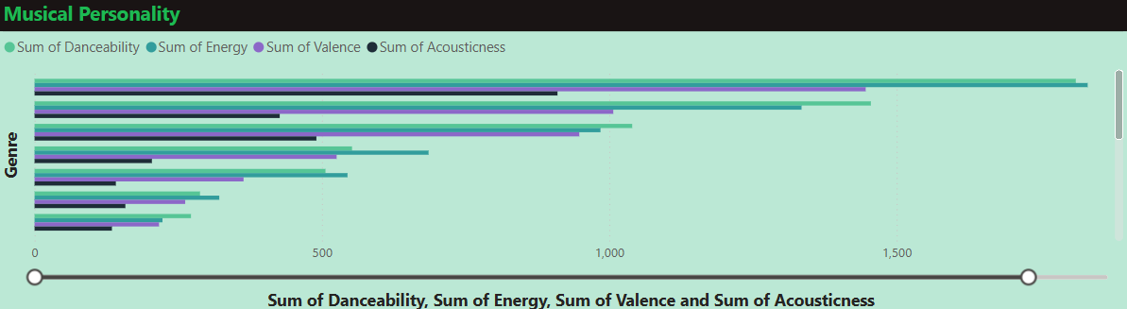

Full Visual Report: With no genre selected:
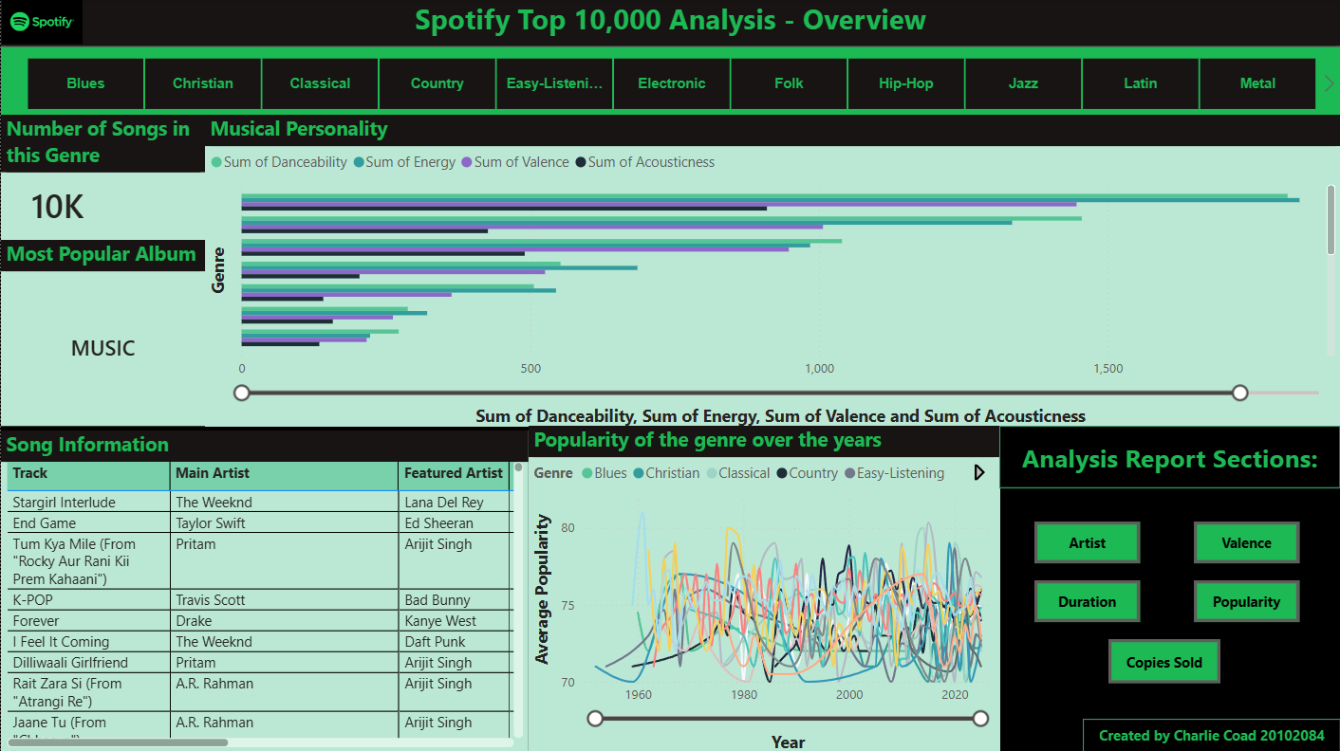

With a genre selected (Pop):
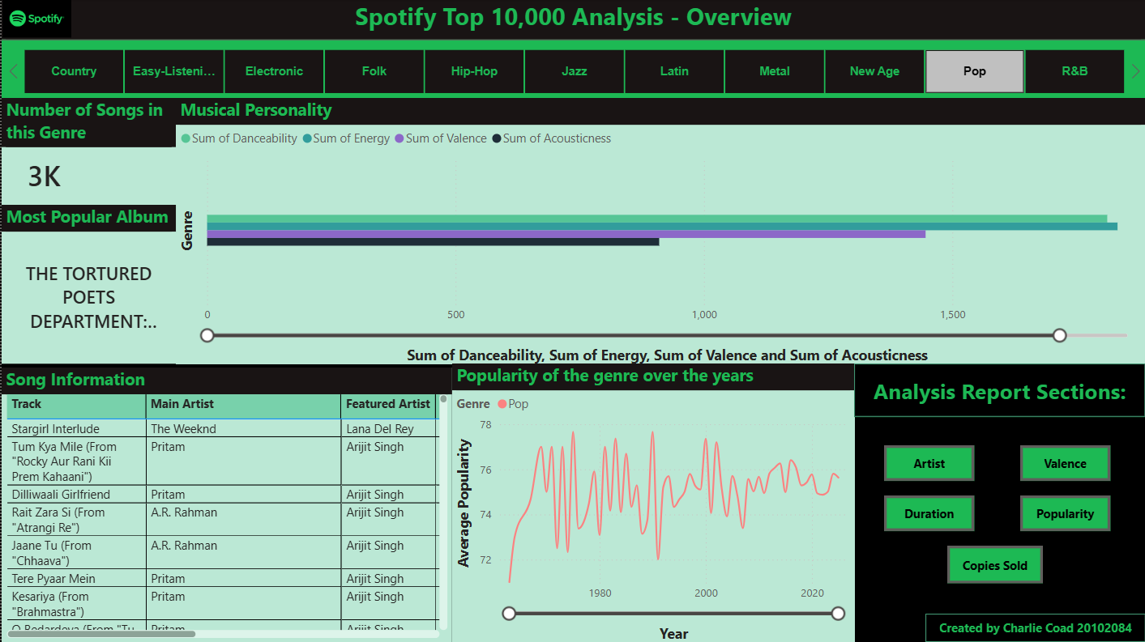

Q1. Artists
The Purpose of this page is to find out what Artists are currently trending in the music industry.
Top 10 Artist by Track Count
This column displays the Top 10 artists within the selected genre. I did this by first selecting the Clustered bar chart visual and selecting the Main Artist column in the Y-axis and in the Legend, then Track Count Column in the X-axis. However in order to ensure that the visual would show only the top 10 I navigated to the filters section and creating a new filter with the following filters:
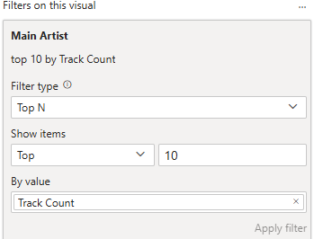
This means I wanted to only see the Top Number of 10 within the Track Count column. The visual looks now like this with no genre slicer selected:
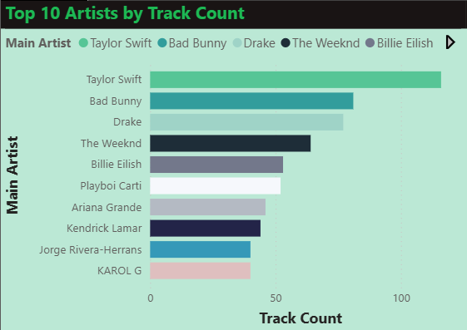

Top 10 Most Followed Artists:
This clustered column chart aims to look at who are the most followed artists on the Spotify Platform. To create this I put the Main Artist column as the X-axis and the Sum of Total Artist Followers as the Y-Axis. Next I filtered the Artist column using the Top N filter to only showcase the Top 10 artists to not over condense the visuals on the graph.
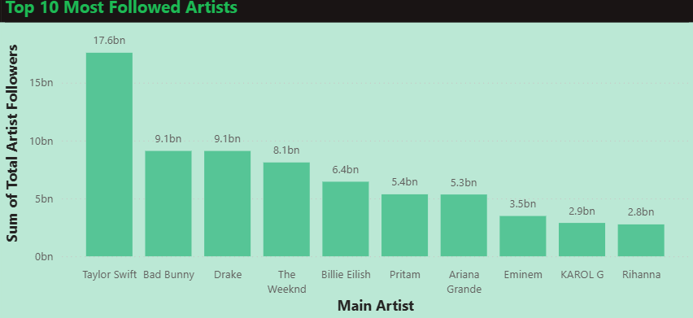
Top 15 most Popular Featured Artists
For the final visual on this page I decided to look into what artists are the most popular to be featured on a song. To create this graph I utilised the Funnel visual and put Featured Artist in for the Category and the Sum of Avg Artist Popularity.
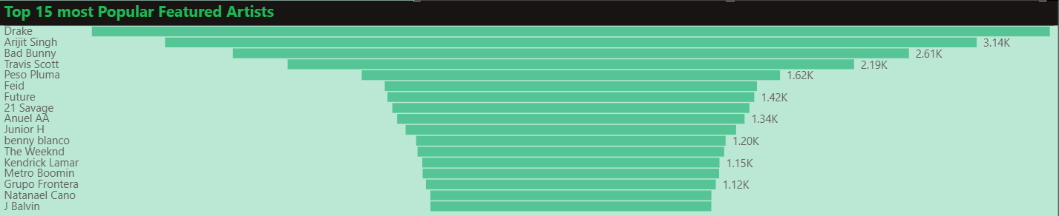

Full Page Report:
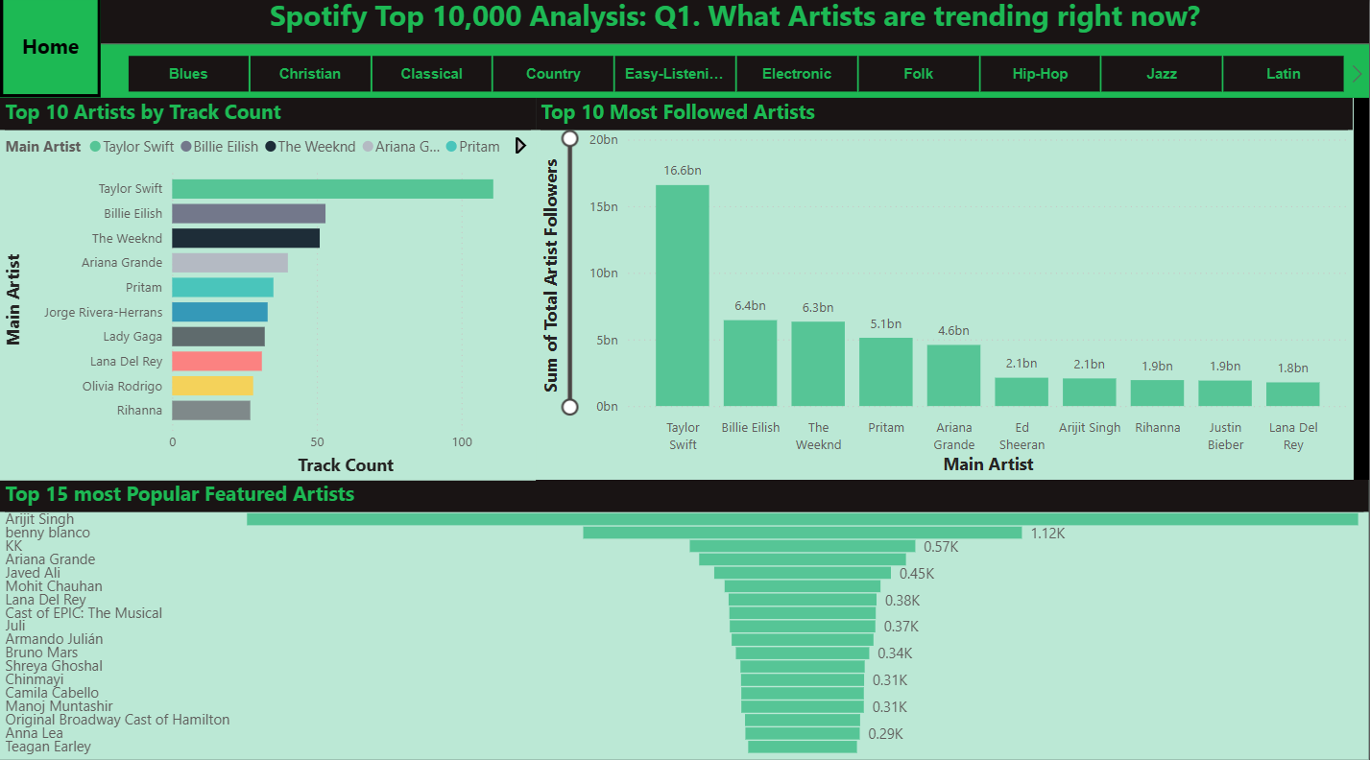

Q2. Valence
Q2. What is the Valence level of this genre?
I wanted find what was the valence level of specific genres, I utilised a Pie Chart to represent this best where I selected my Valence Score column and my Genre column in the Legend, then selected Average Valence as the Values and the Genres column in the Details area. I also used a text box to write in further depth on what this graph is about in greater detail and my findings.
For the Valence Questions I decided to divede them into 2 sections as the next Question utilises a Key Influencer Visual which is very large and descriptive so I gave it its own page. I created a navigation button to allow the User to navigate to this section on the Right hand side of the screen
An important thing to note is as I have selected 2 columns into the Legend area, this graph has the Drill-down function enabled so you can check what genre is selected. In the below visual, the visual is filtered into the Pop genre.
Full Report Visual:
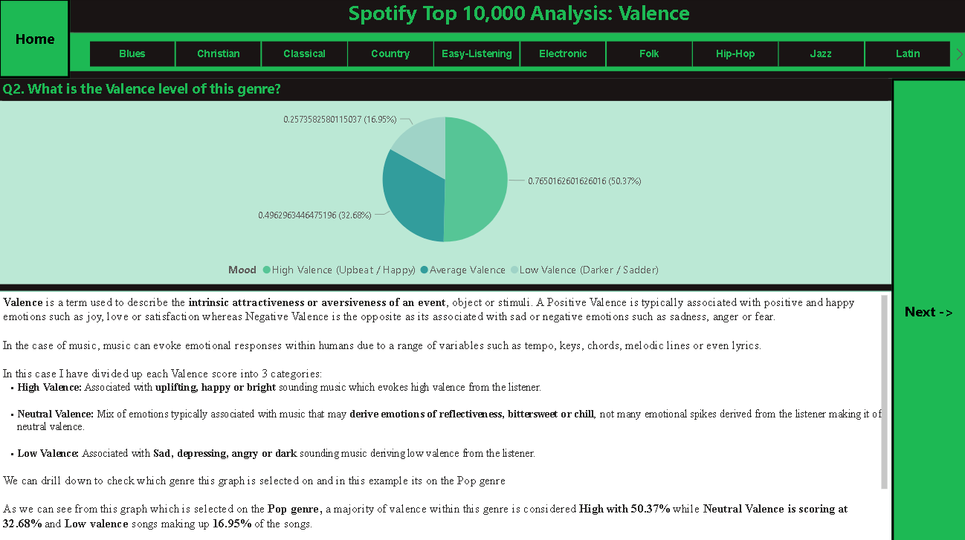

Q3. Valence continued…
Q3. What Key factors heavily influence Valence?
This question I answered entirely with a graph as I utilised the Key Influences visual and wanted to analyse a few different variables and how they influence Valence. First I put the Valence column into the Analyse section.
I then chose the Sum of the following columns and inserted them into the “Explain by” section:
- Tempo
- Key
- Mode
- Loudness
- Speechiness
- Danceability.
This generated a large interface where I could see specific statistics on what to what degree do these variable’s influence Valence to increase or decrease. I didn’t accompany this graph with a textbox as it details this for me. I have also added a navigation button to allow the user to go back to the previous Valence Question.
Below are the variables that increase Valence:
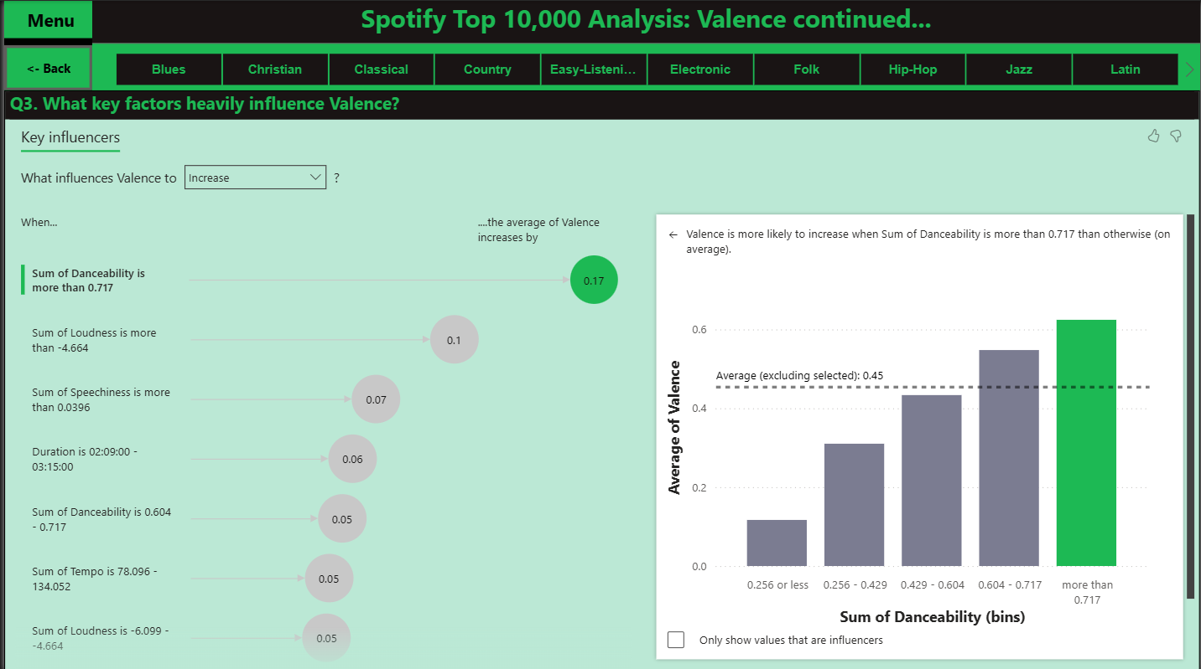
Below are the variables that decrease valence:
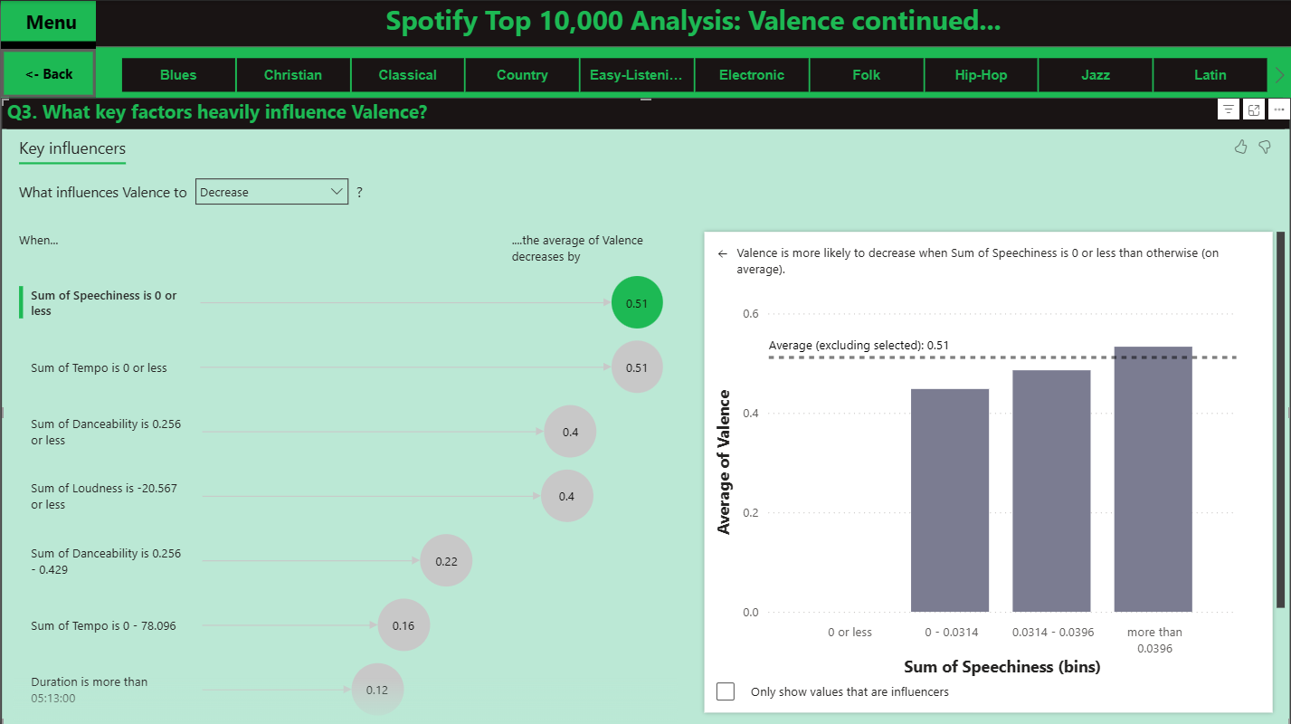

Q4. Duration Page:
For the topic of Duration I wanted to analyse: What should be the average duration of a song? Aswell as looking at how this effects the popularity of music. To create this visual I utilised a Clustered Column chart to represent the time length of the music. I put the Duration column in the X-axis, Sum of Populatity as the Y-axis and finally having the Genre as the Legend. This created a large graph showcasing where every song aligns in terms of duration. I also have a text box below explaining how to interpret the graph and my findings while analysing the Pop genre.
Below I will showcase the full Report view:
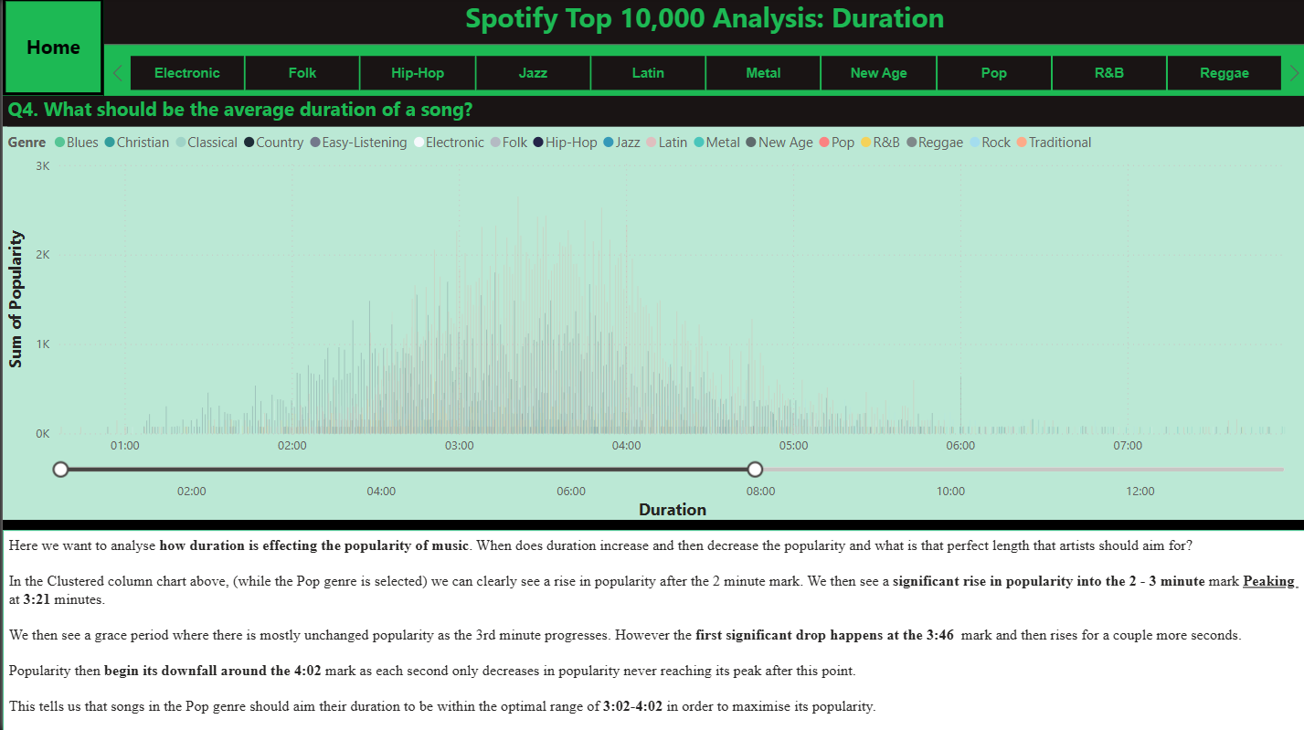
While the Pop genre is selected:
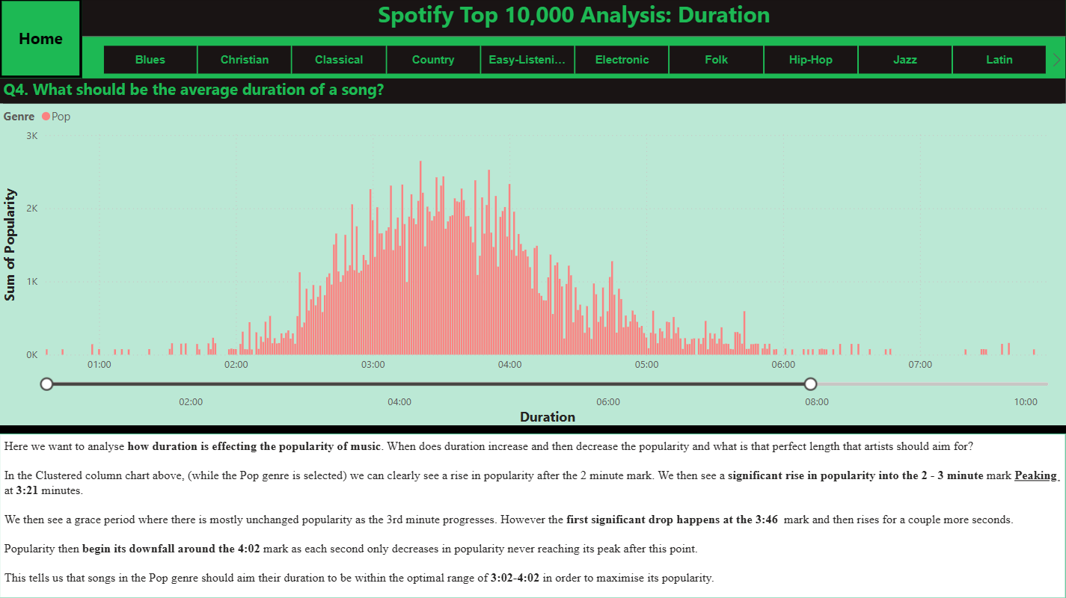

Q5-Q7 (Popularity) Page:
Q5. How does Energy and Danceability drive Popularity?
A more in-depth question I wanted to visual was how energy and danceability drive popularity within different genres. To create this visual I selected the Scatter Graph visual and selected the Energy column into the X axis and the Sum of Danceability column into the Y Axis. Next I inputted the Genre column as the legend and the Sum of Popularity into the Size. Conditional Formatting and Titling provides this visual in the Hip-Hop genre selected in the slicer:
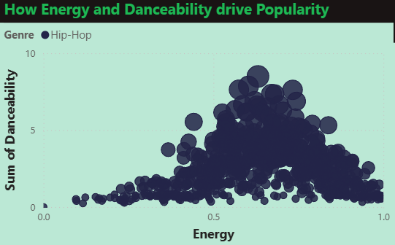
The explanation behind this visual first tells us that there is a Positive Correlation between the Energy and Danceability axis because as the Energy increases, so does the Danceability. Another thing we can see here is that the greater the circle size the greater the popularity of the song. We can see that most of the larger bubbles can be found after the energy is greater than 0.5 and the danceability is above 5. This tells us that Energy and Danceability do indeed drive Popularity.
Below this I have a text box where I explain what’s happening in the graph and its findings

Q6. How does Tempo/BPM effect Popularity?
For this visual I wanted to answer the question: How does Tempo/BPM of a song effect is popularity: To do this I selected another scatter graph visual. Here the Tempo column was the X Axis, the Sum of Popularity was the Y-axis, the Legend was the genre and the Size was the Sum of Energy. After conditional formatting and titling this was the result for specifically the Hip-Hop genre:
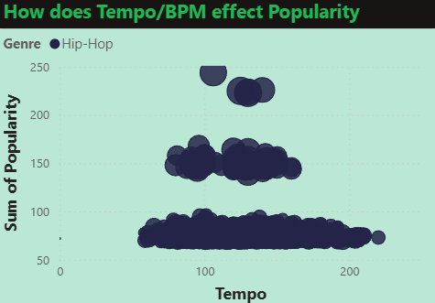
For this graph we are seeing a few different things happening. So as previously mentioned. The larger the circles, the more popular that song is. We are seeing 3 sets of clusters which tells us where popular music tends to trend around depending on popularity. The bottom layer shows us the less popular songs which tend to range in tempo from roughly 60-230, However in the cluster above this we see the more popular songs range between roughly 90-175, Finally the much smaller cluster and the most popular songs within the Hip-Hop genre range between the sweet spot of 110-150.
Songs that range around the 120 BPM are often associated with more club/dance orientated music which lines up with the previous graph showing that the more danceable a song is the more popular it was which in this instance tells us that tempo/BPM does influence popularity if it ranges between the sweet spot of 110-150.
Below this I have a text box where I explain what’s happening in the graph and its findings

Q7. Does a songs explicit lyrical content effect its overall popularity?
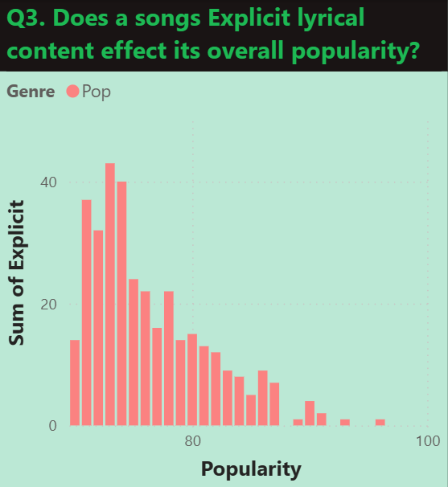
For this graph I wanted to find out if explicit lyrics impact popularity. In order to create this I utilised the clustered column chart and used Popularity for the X-axis, Sum of Explicit for the Y-Axis and the Genre column as the legend.
I utilised the Pop genre for this example. This graph indicates that the more explicit the song, the less popular it will be overall however as the explicit content decreased, the popularity gradually increases.
This makes sense as explicit music cannot be played in specific places such as a local radio station, in public areas and around children, this decreases the likelihood it will be heard by conventional means, reducing the likelihood of it becoming popular.
Below this I have a text box where I explain what’s happening in the graph and its findings

Full Visual Report:
With no genre selected:
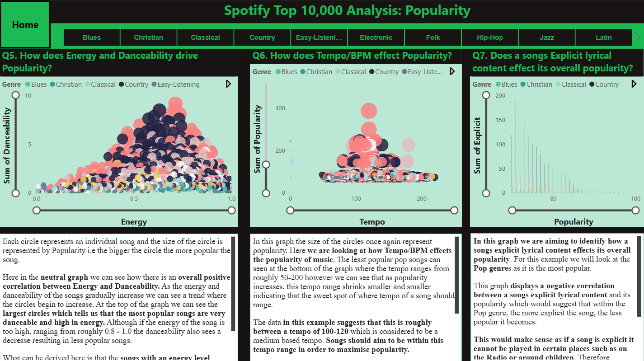
With the Pop Genre selected:
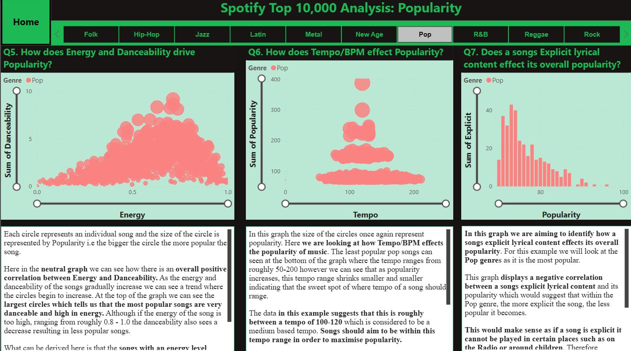

Q8. Copies Sold
Q8. What factors influenced how many copies of a song are sold?
For my final visual I once again utilised the Key Influencer visual to analyse what factors will influence the number of copies a song will sell. As the Record Labels main aim is to sell records and music, they now want to translate this into sales. For the key influencer visual I put the Copies column into the “Analyze” section and the following into the “Explain by”
- Sum of Loudness
- Sum of Speechiness
- Sum of Danceability
- Duration
- Average Valence
- Average Popularity
- Sum of Avg Artist Popularity
Now in the results I haven’t selected a genre as some of the outcomes of selecting a genre have provided little to no results. This tells us that the following information goes for all genres and that genre has little to no effect and do not factor into copies sold.
What influence copies sold to Increase:
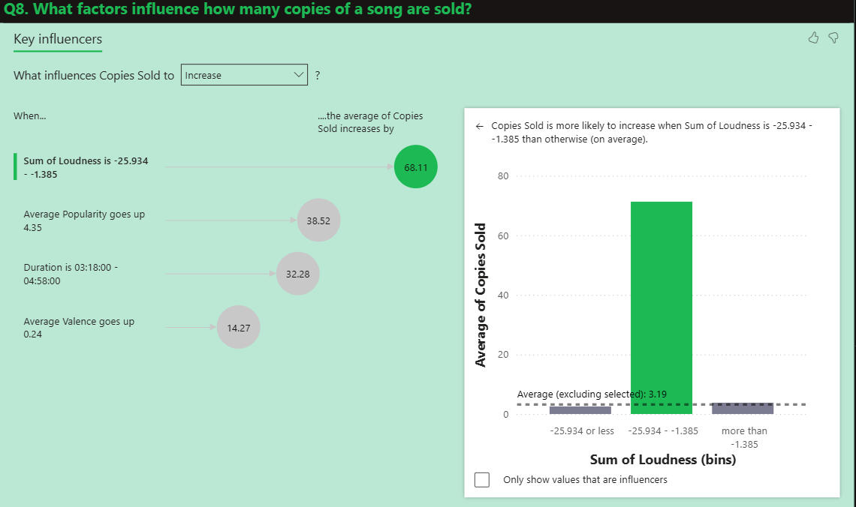
What influences copies sold to Decrease:
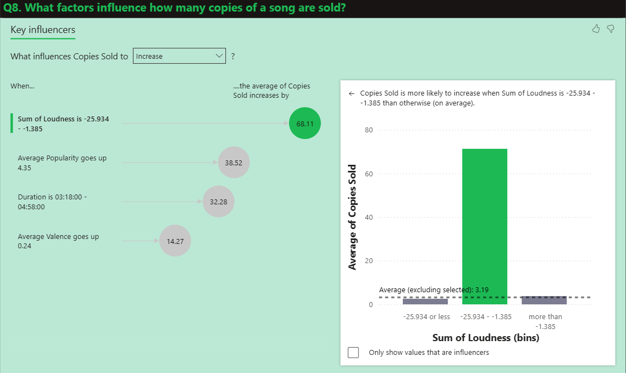

I have also added a Table beside this to showcase the Top 25 Artists with the most Sold Copies, filtering the Top N by 25.

Full Page Report:
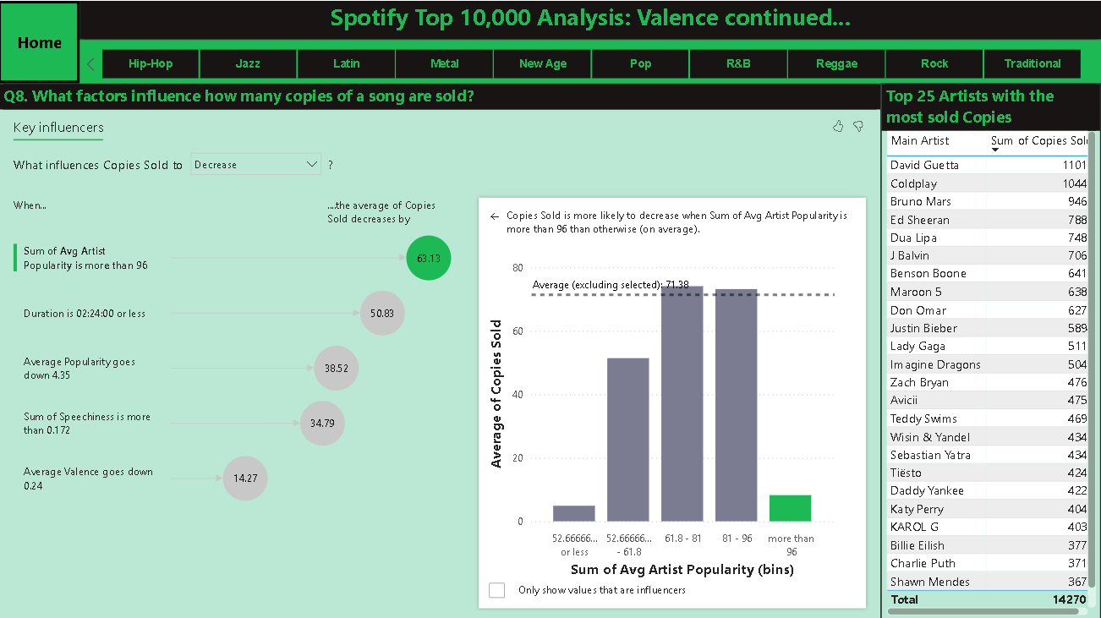

Conclusion
In Conclusion, I believe that this report meets this projects objective because I have identified and analysed how Artists, Valence, Duration, Popularity and Copies sold all have all contributed to different genres of music being in the Top 10000 on Spotify. This will enable the Record Label to explore further patterns and trends within the music industry and allow them to make better informed decisions going forward.
Within this report I have demonstrated my ability to utilise PowerBi in order to import, transform and analyse data in order to create a professional and user-friendly report that allows users to interact with the reports content in order to identify patterns and trends in their respective sections.
I utilised Power Query to transform data, DAX queries in order to create new measures and columns. I then utilised many different diagrams such as Tables, cluster columns charts, scatterplots, line graphs, key influencer charts and Pie Charts in order to gain a better understanding of the data from a visual perspective.

Link to Published Project:
Important Note: The Key influencer visual isn’t compatible with published PowerBi reports which is why Q3 and Q8 are giving an error here. This is because the visual is not supported when a live document is connected to Azure Analysis Services/SQL Server Analysis Services and published to the web. However you can see from my Submitted PowerBi documentation on Moodle, these do function correctly and provide answers.
https://app.powerbi.com/view?r=eyJrIjoiZTEwYWU2MDEtYjJhYi00NzY0LTk0MzAtZWZkMDcwY2NkN2Q4IiwidCI6IjA1ZjhjMjM5LWNiMTctNDc1NS1hMzQ1LTA0ODc1MjA2M2MzYiIsImMiOjh9

